**CS 20 Web Programming  
Assignment: SQL Practice**

## Objectives: Learn how to create a database, write and run SQL queries Tasks

**Part 1: Queries (30 points)**

For each of the following, show the SQL statement to solve the problem and a screenshot of the results:

*Using the Northwind database online, solve the following:*

1. Display the company name, contact name, and city for all CUSTOMERS.
2. Display id for all German SUPPLIERS
3. Display name and price of all PRODUCTS whose price is between $10 and $20 (inclusive) sorted from highest to lowest price
4. Display the PRODUCT name and price for suppliers 10-15 sorted by supplier number and product name (ie, if the supplier number is the same, it should then order by name). Do this with only one query.
5. Display the name of all EMPLOYEES with a BA or BS degree (hint: use the notes field) sorted alphabetically by their last name.

**Part 2: Create a database (60 points)**

1. Create an ERD to represent your product list (from the JSON assignment).  
   Note: to have more than one category for an item you will need an extra table plus an assignment table.
2. In your cpanel hosting, set up a database and create the tables you will need. Add your data to the tables.
3. Create and run queries to show all data in each of your tables.
4. Create and run the following queries:
5. show all product names and their price
6. show all product names and all categories that correspond to them - hint: you will need a join for this.

**Extra Credit:** Display query 4a in a table with 2 columns (the product name and the price) on a page. Prices should be exactly 2 places after the decimal point and have a $

**Rubric**

Deliverables: 10 points  
Part 1: 30 points  
Part 2: 60 Points  
E/C: 10 points

**Deliverable Worksheet:**

* All code files uploaded to canvas (php/css) – you may use a zip file
* ERD diagram for part 2 (paste below)

**Part 1 Queries:**

1. Display the company name, contact name, and city for all CUSTOMERS.  
   A screenshot of a computer

   Description automatically generated  
   SELECT CompanyName, ContactName, City FROM customers;
2. Display id for all German SUPPLIERS

SELECT SupplierID FROM suppliers WHERE country = 'Germany';

1. Display name and price of all PRODUCTS whose price is between $10 and $20 (inclusive) sorted from highest to lowest price

SELECT ProductName, UnitPrice FROM products WHERE UnitPrice BETWEEN 10 AND 20 ORDER BY UnitPrice DESC;

1. Display the PRODUCT name and price for suppliers 10-15 sorted by supplier number and product name (ie, if the supplier number is the same, it should then order by name). Do this with only one query.  
   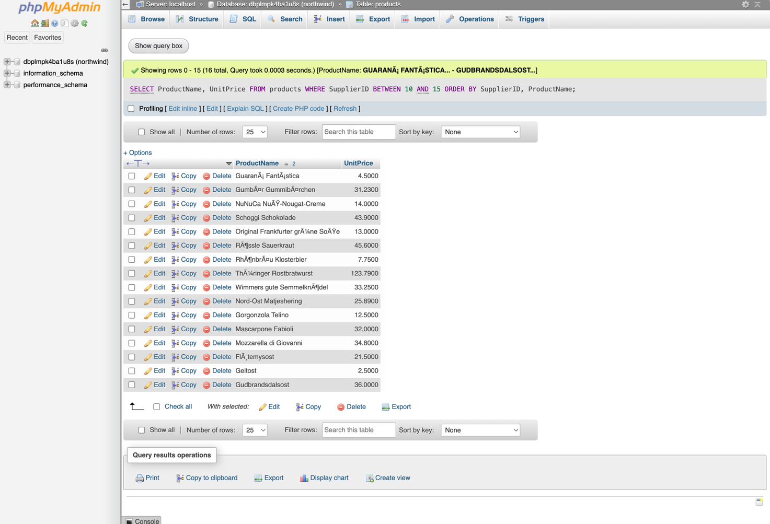

SELECT ProductName, UnitPrice FROM products WHERE SupplierID BETWEEN 10 AND 15 ORDER BY SupplierID, ProductName;

1. Display the name of all EMPLOYEES with a BA or BS degree (hint: use the notes field) sorted alphabetically by their last name.

SELECT LastName, FirstName FROM employees WHERE Notes LIKE '%BA%' OR Notes LIKE '%BS%' ORDER BY LastName;

**Part 2 Queries**

1. Show all product names and their price  
     
   A screenshot of a computer

   Description automatically generated

[SELECT](https://gvam1009.siteground.biz/phpmyadmin/url.php?url=https://dev.mysql.com/doc/refman/8.0/en/select.html) ProductName, Price FROM products;

1. Show all product names and all categories that correspond to them - hint: you will need a join for this.

* **SELECT p.ProductName, c.CategoryName**
* **FROM products p**
* **JOIN productCategories pc ON p.ProductID = pc.ProductID**

**JOIN categories c ON pc.CategoryID = c.CategoryID;**

URL for Extra Credit (optional) _____________________________________________